Project Design Phase-II
Data Flow Diagram & User Stories
Date | 07 September 2026
Team ID
Project Name | Automated Network Request Management in ServiceNow
Maximum Marks | 4 Marks

Data Flow Diagrams:
A Data Flow Diagram (DFD) represents how information enters, is processed, stored, and moves through the proposed solution. The following Level 0 DFD shows the main flow of a network request from submission through approval and fulfillment.
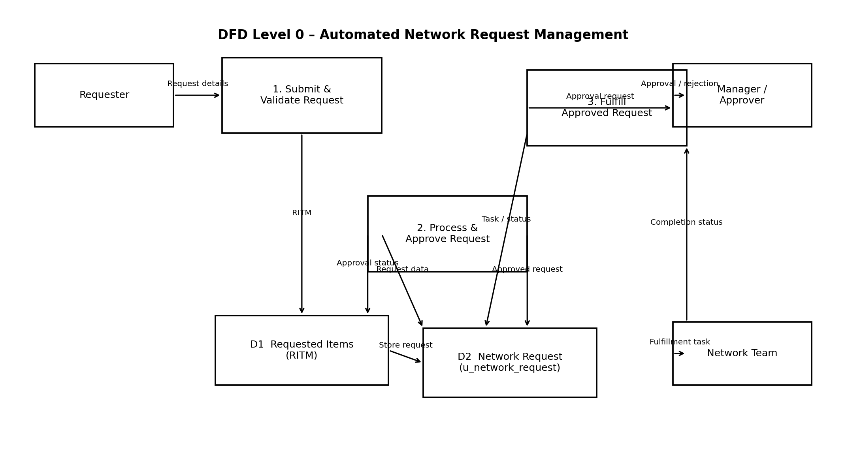

User Stories
The following user stories are defined for the Automated Network Request Management solution.
User Type | Functional Requirement  (Epic) | User Story  Number | User Story / Task | Acceptance criteria | Priority | Release
Network Requester | Network Request Submission | USN-1 | As a requester, I can submit a network request through the Service Catalog. | A new RITM is created after successful submission. | High | Sprint-1
Network Requester | Network Request Submission | USN-2 | As a requester, I can select the type of network request I need. | Request Type provides the configured request options. | High | Sprint-1
Network Requester | Dynamic Form & Validation | USN-3 | As a requester, I can see only the fields relevant to the selected request type. | Relevant fields are displayed and required fields become mandatory. | High | Sprint-1
Network Requester | Dynamic Form & Validation | USN-4 | As a requester, my information can be populated from my user record. | Name, email, phone, department and manager are populated when available. | Medium | Sprint-1
Network Requester | Dynamic Form & Validation | USN-5 | As a requester, I can enter valid firewall IP addresses and port numbers. | Invalid IP addresses or ports outside 1–65535 are rejected. | High | Sprint-1
Manager / Approver | Approval & Fulfillment | USN-6 | As a manager, I can review a submitted network request and approve it. | The approval request is available to the assigned manager and can be approved. | High | Sprint-1
Manager / Approver | Approval & Fulfillment | USN-7 | As a manager, I can reject a network request when it is not appropriate. | The request moves to Rejected after rejection. | High | Sprint-1
Network Requester | Approval & Fulfillment | USN-8 | As a requester, I can see the current state of my network request. | The request state reflects New, In Progress, Awaiting Approval, Completed or Rejected. | High | Sprint-2
Network Team | Approval & Fulfillment | USN-9 | As a Network Team member, I can receive a fulfillment task for an approved request. | A catalog task is created and assigned to the Network Team after approval. | High | Sprint-1
Network Team | Approval & Fulfillment | USN-10 | As a Network Team member, I can update work notes and complete the fulfillment task. | The task can be updated and completed, and the request progresses to Completed. | High | Sprint-2
Network Requester | Notifications & Monitoring | USN-11 | As a requester, I can receive notifications about important request events. | Configured email notifications are generated for approval, rejection and completion events. | Medium | Sprint-2
Network Manager | Notifications & Monitoring | USN-12 | As a manager, I can monitor pending network requests and approvals. | Pending requests and approvals can be viewed through lists and dashboard visualizations. | Medium | Sprint-2
Network Team | Notifications & Monitoring | USN-13 | As a Network Team member, I can monitor requests by state, type, priority, device and environment. | Reports/dashboard provide the configured request breakdowns. | Medium | Sprint-2
Administrator | Security & Access Control | USN-14 | As an administrator, I can manage roles and groups for requesters, approvers and fulfillers. | Configured roles and groups control access to request, approval and fulfillment activities. | Medium | Sprint-2

